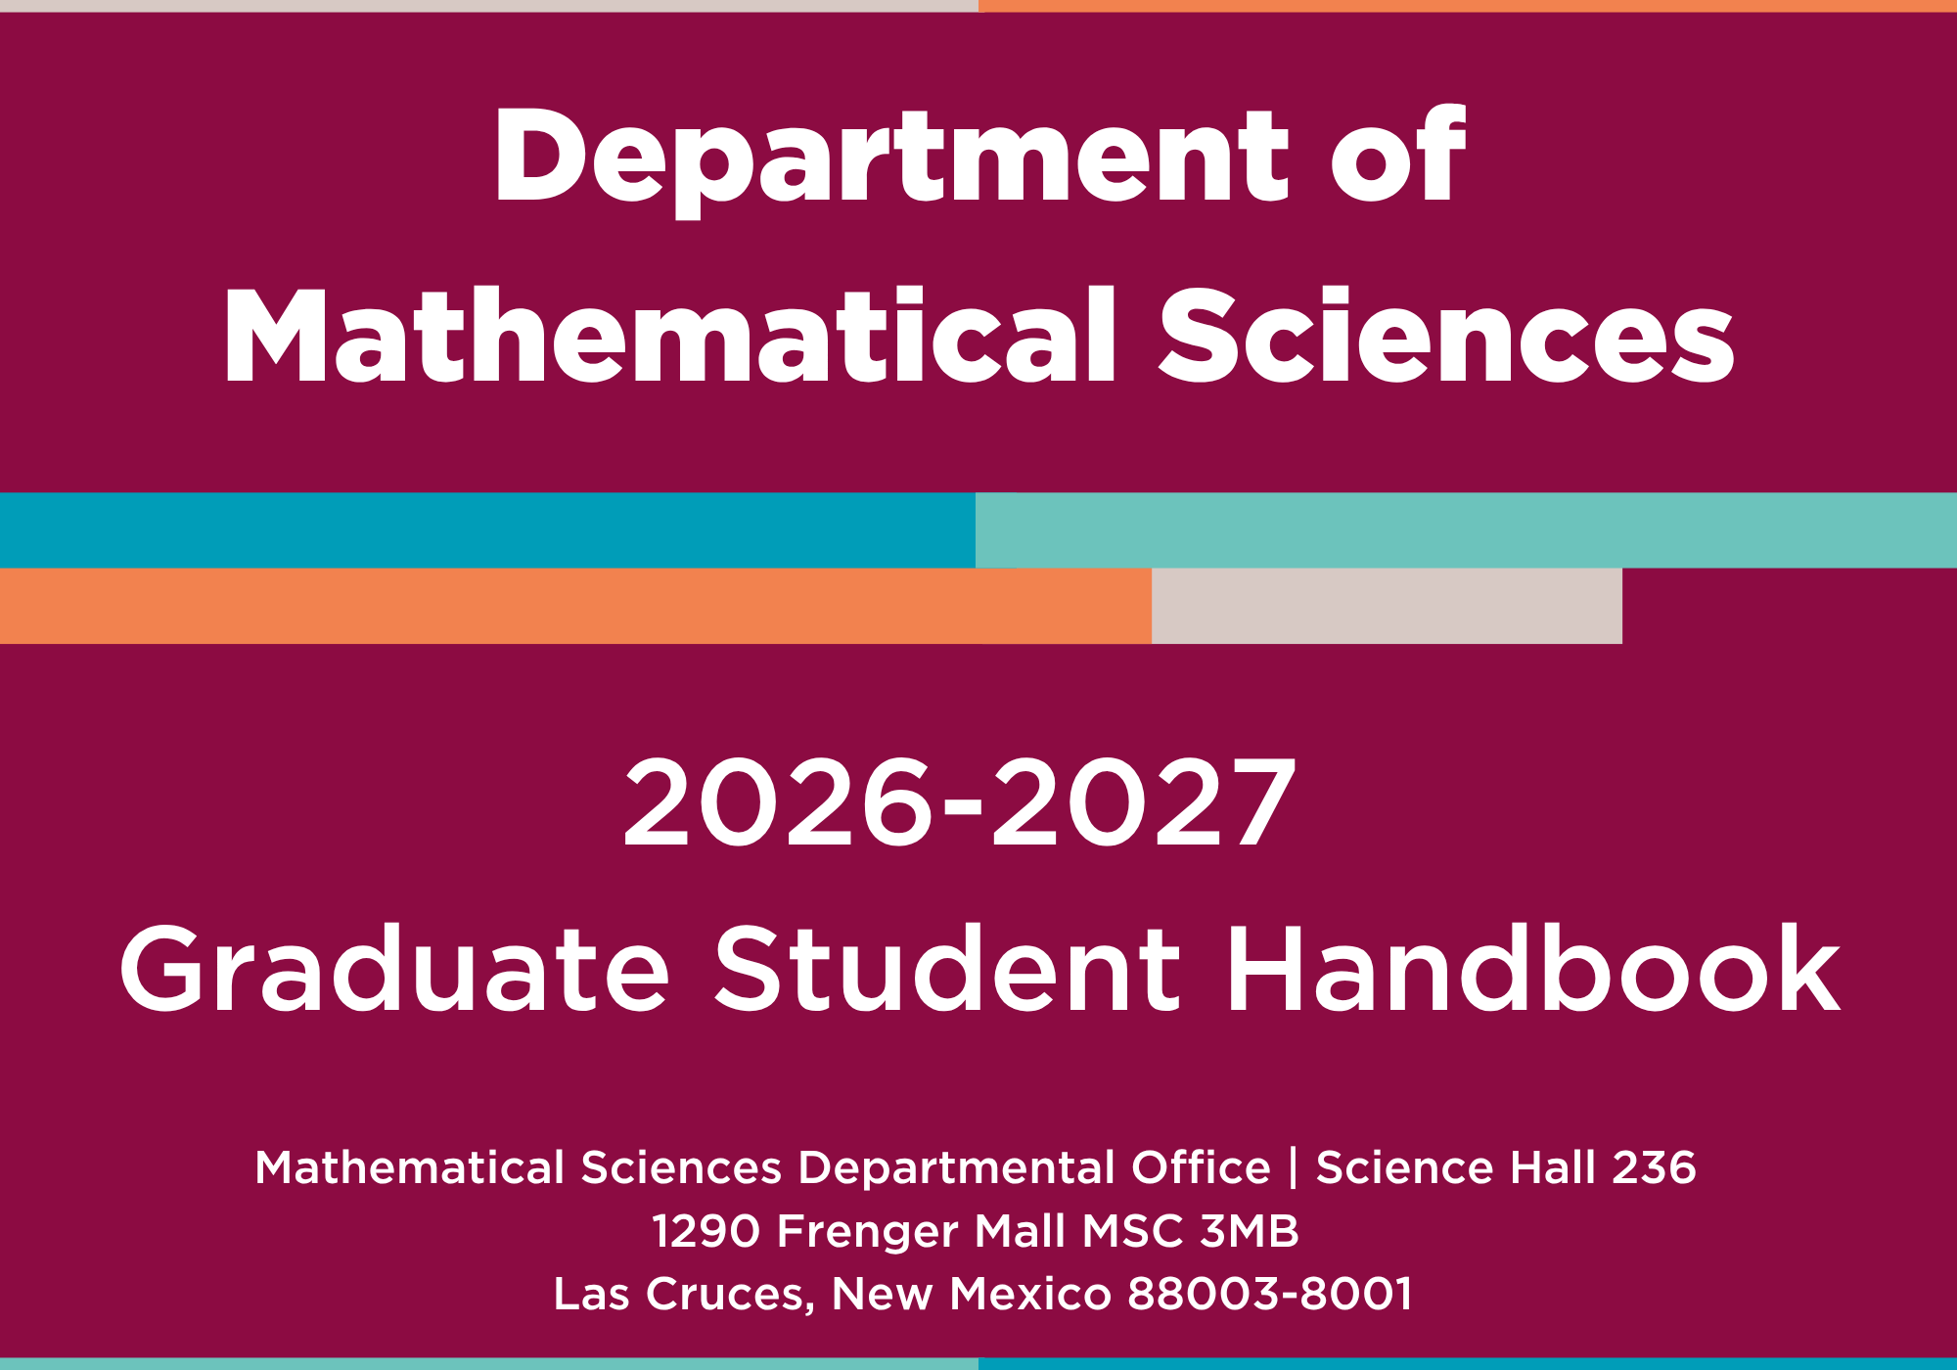
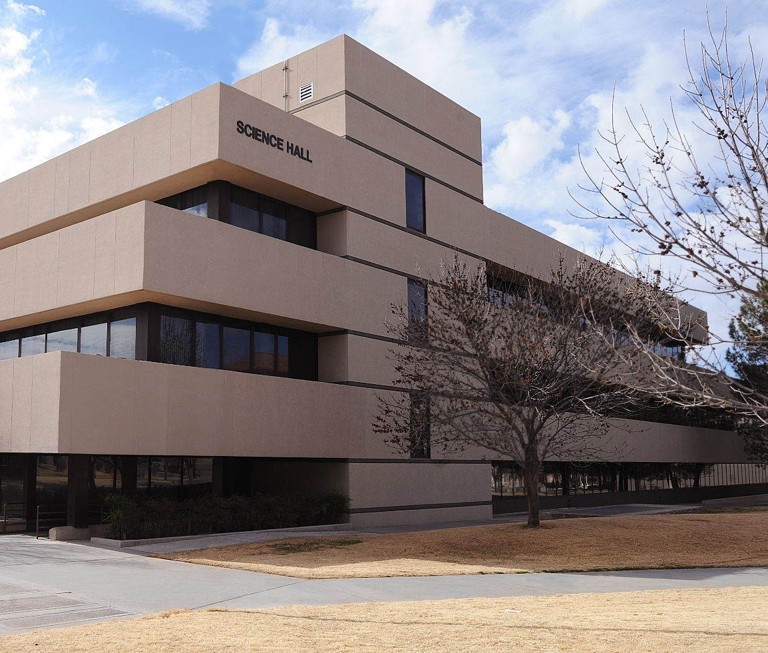

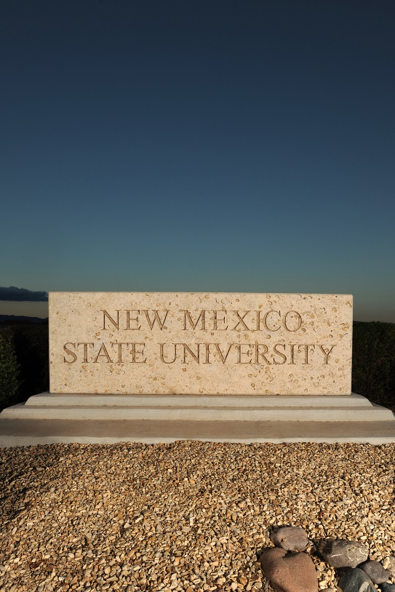

Table of Contents

The Department of Mathematical Sciences
Program Overview
Admission Requirements
Degree Requirements
I. General Requirements for Graduate School
II. Establishment of Advisor
III. Requirements for Master of Science (M.S.)
A. Course work
B. Thesis and non-thesis options
C. Examinations
D. Formation of a graduate committee
E. Degree application
IV. Requirements for Doctor of Philosophy (Ph.D.)
A. Course work
B. Research topic and thesis
C. Examinations
D. Formation of a graduate committee
E. Degree application
Financial support
Graduate Assistantship
I. Orientation
II. Appointment letters
III. Summer support
IV. Resources for graduate assistants
International Students
Research
I. Seminars and Colloquia
II. Conferences and Workshops
III. Other opportunities
What everyone should read
Student Resources

The Department of Mathematical Sciences
The Department of Mathematical Sciences is part of the NMSU College of Arts and Sciences, and it is located on the second floor of Science Hall. It offers courses in mathematics and statistics leading to the Bachelor’s, Master’s and Doctoral degree. At the Bachelor’s level we have several options for career preparation, such as actuarial science, applied mathematics, foundations, general mathematics, probability and statistics, and secondary mathematics education.
Our faculty has research groups in many areas of pure and applied mathematics, and in mathematics education. Strengths lie in commutative algebra, logic and foundations, probability and statistics, dynamical systems, mathematical biology, variational methods in partial differential equations (especially relevant to materials science) and nonlinear analysis relevant to mathematical physics and topology.
We provide courses for other disciplines throughout the NMSU main campus such as sciences, engineering, social sciences, humanities, agriculture, business, and education. This includes preparatory and general education courses that ensure every student has the quantitative reasoning skills that every career now demands.
The department’s mission is to provide core education in mathematics and statistics that prepares graduate and undergraduate students to be knowledgeable and responsible citizens of the world.
Program Overview
The Department of Mathematical Sciences offers both Master of Science (M.S.) and Doctor of Philosophy (Ph.D.) degrees. We currently have about 40 graduate students and 18 tenure-track faculty members. Most of our graduate students are supported by full assistantships. The department has active research groups in the following areas: Algebra, Analysis, Applied Mathematics, Logic and Foundations, Probability, Statistics, and Topology.
Students applying for regular admission to graduate study in mathematics are expected to have 24 credits of upper-division courses in mathematics and statistics, including three-credit proof-based courses in modern analysis and modern algebra. Students who do not meet these requirements may be admitted with deficiencies and allowed to complete the requirements at New Mexico State University.
Applications must be submitted online, see https://gradschool.nmsu.edu/future-students/How%20To%20Apply.html.
Deadlines for domestic and international students can be found here: https://catalogs.nmsu.edu/nmsu/arts-sciences/mathematical-sciences/
All applicants are automatically considered for assistantships. Our department usually pays $1,000-2,000 over university guidelines (https://gradschool.nmsu.edu/ga-and-union/NMSU-and-United-Electrical-Radio-and-Machine-Workers-of-America-Collective-Bargaining-Agreement-2025.pdf). The bargaining agreement (https://gradschool.nmsu.edu/Guidelines-on-Employment-of-Graduate-Assistants-January-2025.pdf) provides some benefits in terms of tuition, etc.
Graduate Workers Union representatives can be found here: https://gradschool.nmsu.edu/ga-and-union/grad-assistants-union-representatives.html
For more information on our programs and facilities, and to learn more about the research interests of the faculty, please see our website at https://math.nmsu.edu, phone us at (575) 646-3904, or write to gradcomm@nmsu.edu.

Admission Requirements
To be considered for admission to the MS or PhD program, incoming students are required to meet the following minimum requirements:
- Application. All prospective students must apply for admission to the NMSU Graduate School https://gradschool.nmsu.edu/ and pay the corresponding application fee.
- A bachelor’s degree from an accredited institution of higher education with a cumulative grade point average of 3.0 or higher on a 4.0 scale.
- Official transcripts for each university attended (uploaded to the online admissions system).
- Three letters of recommendation.
- A personal statement or letter of interest covering academic background and career goals. Please include a brief statement on your research interests.
- Brief resume or curriculum vitae that summarizes the candidate's background and qualifications.
- A TOEFL score or equivalent for many international students. See link for details: https://gradschool.nmsu.edu/future-students/requirements/english-proficiency-trascript-evaluation.html
- GRE scores are NOT required.
Note: GRE scores are optional. Applicants may additionally submit evidence of research such as a thesis or publication.
Should I apply to the Master’s program or the PhD program?
Applicants with a Master’s degree in mathematics should apply to the Ph.D. program. Candidates without a Master’s degree in mathematics should normally apply for our Master’s program even if their eventual goal is to obtain a Ph.D. Note that degrees in statistics or applied mathematics are not necessarily considered equivalent to a degree in mathematics.
Our Ph.D. program is structured with the assumption that a student has Master’s level coursework completed and the exams are timed accordingly. Re-application to the Ph.D. is required after completion of our Master’s program, but students that we feel will complete our Ph.D. are normally admitted. An additional advantage of students without a Master’s in mathematics beginning in the Master’s program is that it allows for the possibility of an additional year of state-funded support https://gradschool.nmsu.edu/ga-and-union/grad-assistant-forms/Guidelines_on_Employment_of_Graduate_Assistants%20Jan%202023.pdf.
For Master’s students currently at NMSU and applying to the PhD program
It is very beneficial to your application to have identified a possible advisor or research group that you wish to work with and to have faculty from this area among your references.

Degree Requirements

I. General Requirements for Graduate School
The general New Mexico State University requirements for the Graduate School are described in the Graduate Catalog. For the most recent catalog visit: https://catalogs.nmsu.edu/.
Students should familiarize themselves with these requirements. For information regarding Graduate Student Orientation, contact the Graduate School at gradinfo@nmsu.edu.

II. Establishment of Advisor
The process of selecting a research advisor is crucial for graduate students. It is recommended that admitted students proactively reach out to potential advisors who share their research interests. The chosen advisor should have expertise in the student's research area and direct the student’s thesis in the future (if applicable). In cases where an advisor is not yet determined, an interim advisor will be assigned by the department. The interim advisor is a temporary role that intends to provide academic guidance until a permanent advisor is established. Advisor information is kept on our webpage at. https://math.nmsu.edu/people/graduate-students.html. Please report any discrepancies.

III. Requirements for Master of Science (M.S.)

A. Course work
In fulfillment of the Graduate School requirement of a minimum of 30 semester credits of course work, the student must take at least 24 credits of mathematics or statistics from the courses listed here: https://catalogs.nmsu.edu/nmsu/graduate-school/mathematics-master-science/.

A candidate for a master's degree may select up to two minors in addition to the major. A minimum of 8 credits of graduate work is necessary for a minor. The student's program of study must be approved by the departmental Graduate Studies Committee.

B. Thesis and non-thesis options
A Master’s thesis is optional. Up to 6 credits of Math 599 Master’s Thesis may count towards the 30-credit requirement of the Graduate school for the Master’s degree and the Master’s Final Examination may be based on the Master’s thesis. In general, a Master’s thesis, unlike a Ph.D. thesis, can be expository. For students aiming to write a Ph.D. thesis, a Master’s thesis can be good preparation.

C. Examinations
The student must successfully complete a master's written examination and master's final examination (oral examination administered by the student's committee, see part D below). These should be coordinated with the help of the student’s advisor, but the student has the primary responsibility for complying with the corresponding deadlines. For deadlines and exam registration please contact Ms. Paloma Pavao (pavao@nmsu.edu). More details for these examinations can be found here: https://catalogs.nmsu.edu/nmsu/graduate-school/mathematics-master-science/.

D. Formation of a graduate committee
The student's committee consists of at least four members: The committee chair (advisor), two departmental members and a faculty member from another department who serves as the Dean's representative. See the graduate catalog for rules governing the Graduate Dean’s representative. The graduate committee is selected by the student and the student’s advisor, along with approval of the Department Head and the Graduate Studies Committee.

E. Degree application
In addition to the requirements stated above, students must also satisfy the general university requirements for a Master’s degree. These are described in the Graduate Catalog, available through the Dean of the Graduate School or online at https://catalogs.nmsu.edu/. For degree application procedures and deadlines, please refer to https://gradschool.nmsu.edu/Current%20Students/Resources.html.

IV. Requirements for Doctor of Philosophy (Ph.D.)

A. Course work
Course work requirements for the Ph.D. program can be found here:
https://catalogs.nmsu.edu/nmsu/graduate-school/mathematics-doctor-philosophy/

B. Research topic and thesis
The student should discuss and decide in consultation with the advisor a research topic, direction and strategy for the completion of the thesis.

C. Examinations
The student's committee consists of at least four members: The committee chair (advisor), two departmental members and a faculty member from another department who serves as the Dean's representative. See the graduate catalog for rules governing the Graduate Dean’s representative. The graduate committee is selected by the student and the student’s advisor, along with approval of the Department Head and the Graduate Studies Committee.

D. Formation of a graduate committee
Candidates for the Ph.D. degree in the Department of Mathematical Sciences must pass a:
- Qualifying examination
- Basic comprehensive written examination
- Advanced comprehensive examination with written and oral components
- Final oral doctoral thesis examination.
These should be coordinated with the help of the student’s advisor, but the student has the primary responsibility for complying with the corresponding deadlines. For deadlines and exam registration please contact Ms. Paloma Pavao (pavao@nmsu.edu). More details for these examinations can be found here: https://catalogs.nmsu.edu/nmsu/graduate-school/mathematics-doctor-philosophy/.

E. Degree application
In addition to the requirements stated above, students must also satisfy the general university requirements for a Ph.D. degree. These are described in the Graduate Catalog, available through the Dean of the Graduate School or online at https://catalogs.nmsu.edu/. For degree application procedures and deadlines, please refer to https://gradschool.nmsu.edu/Current%20Students/Resources.html.

Financial support
Financial assistance options such as assistantships, fellowships, scholarships, and loans may be available to graduate students, but it is important to note that admission to the program does not guarantee any offer or assurance of financial support. Both departmental assistantships and university fellowships are limited and awarded on a competitive basis.
When a student first applies to the program, there is no need to submit a separate application to be considered for departmental funding (assistantship). The allocation of a TA or RA position depends on the applicant's qualifications and the availability of funding. It is primarily determined by the department's specific needs, rather than the student's preference for a particular type of work. Continuation of funding is contingent upon students adequately fulfilling their duties and making satisfactory academic progress.
Upon admission into the program, new graduate students can seek guidance from the financial aid office (https://fa.nmsu.edu/) to explore other forms of financial support outside the department resources, such as federal student loans and NMSU Scholar Dollars.
NMSU uses the Scholar Dollar$ online application system to apply for all scholarships and awards. There are several tuition scholarships and awards for research and teaching excellence available from the Graduate School and the department. In order to be considered for these awards, students must have an active Scholar Dollar$ account that must be updated annually. It is suggested that students apply for the account immediately upon admission into the program. Please go to https://scholarships.nmsu.edu/index.php to access the Scholar Dollar$ Application System.

Graduate Assistantship
The department will assign graduate assistantships with faculty members guiding and evaluating students. Before the semester starts, a student should talk to their supervisor(s) to clarify expectations and ask questions. The supervisor may review the student’s work or observe the student’s teaching, so these opportunities should be used to build confidence and improvement through expert feedback.
Teaching assistant duties may include grading, tutoring, labs, NMSU-Global courses, teaching a section of their own class under coordination, sometimes assisting the dept with administrative duties. Occasionally we have Research Assistant positions.
I. Orientation: All new graduate assistants must attend a mandatory orientation or participate in an online, asynchronous orientation offered by the Graduate School. The in-person orientation is offered during the first few weeks of the Fall semester. Students only need to attend the orientation once; they do not need to repeat the orientation each year. Departments may also require students to complete training workshops, seminars, and orientations to receive an assistantship. If a student becomes a new GA in the spring or summer semesters, they are required to participate in the online training and provide their department with a certificate of completion.
II. Appointment letters: As will be notified in writing of a confirmation of employment. Appointment letters will normally be issued by the hiring department at least fourteen (14) days prior to the start dates of the assistantship, however, nothing will prohibit the offer of appointment letters for assistantships created with less than fourteen (14) days remaining before the start date (CBA, Article 9).
III. Summer support: The department often has opportunities for GAs to do some additional work in the summer. This can range from tutoring to teaching to research support. This is optional for students. An e-mail is sent in April asking for interest and availability and assignments are made in early May.

IV. Resources for graduate assistants
GA resources and Important information can be found here:
https://gradschool.nmsu.edu/ga-and-union/graduate-assistant-resources.html
Please access the Guidelines on Employment for Graduate Assistant document for more information about the following topics: Eligibility for Appointment; GA Appointment Letters; Eligibility for In-State Tuition; How to Apply for a Graduate Assistantship; Minimum Salary Requirements; Enrollment Requirements; Number of Years of Support; Maximum Hours of Employment and Workload; Benefits; Roles and Responsibilities; Disciplinary Action; Grievance Procedure; Health and Safety; Drug/Alcohol Testing; as well as tax implications of course enrolment. This document aligns with the Union Collective Bargaining Agreement (CBA).
The website also has links to the Graduate Assistant Handbook, along with other graduate student resources.
International Students
The International Student & Scholar Services (ISSS) at NMSU serves as the central hub for the university's international initiatives (http://isss.nmsu.edu). ISSS provides valuable services and guidance to international students coming from approximately 72 countries. In collaboration with international student associations and community organizations, ISSS organizes socio-cultural events for international students and their families. Moreover, ISSS extends various international scholarships to students seeking additional financial support. Students can reach out to ISSS for further details. It's important to note that international students must possess a valid Social Security number to secure employment at NMSU. ISSS can be contacted at 575-646-2834 or via email at isss@nmsu.edu.

Research

I. Seminars and Colloquia
Major research groups in the department hold weekly seminars. The speakers are faculty from our department, graduate students in the department, and visitors to our department. With virtual technology there are often well-known experts from other universities. Seminars are intended to be subject specific. Current research in an area seldom resembles the polished results you encounter in textbooks. When deciding on a research area and advisor, a student is encouraged to attend seminars. Once a student has decided on an area, they should regularly attend seminars in that area. At first, much of the material may seem too advanced, but over time that changes. Attending research talks is part of the process of becoming a research mathematician. Presenting talks in seminars is key preparation to presenting talks at other venues, and for eventual job interview talks. Seminars are announced in the weekly reader (https://math.nmsu.edu/activities/weekly-reader.html) and are listed in our events calendar (https://math.nmsu.edu/activities/calendar.html)
Colloquia are research talks intended for a more general mathematical audience. Speakers are usually well-known researchers from other universities. The purpose of colloquia is to provide a broader picture of research in mathematics beyond the focus of a specific research group. Colloquia are held approximately every other week, usually on Friday 12:30-1:30. Refreshments are served. Colloquia are announced in the weekly reader (https://math.nmsu.edu/activities/weekly-reader.html) and are listed in our events calendar (https://math.nmsu.edu/activities/calendar.html)

II. Conferences and Workshops
There are a variety of venues where students can listen to work of others, and if they are ready, to present work of their own. There is an NMSU-UTEP workshop focusing on mathematics, computer science, and computational science held each semester. In the fall it is at NMSU and in the spring it is at UTEP in El Paso. About 75% of the talks are by graduate students and talks are short, about 15 minutes. It is a very friendly and accessible environment and a great way to start filling out a CV for eventual job applications.
Within NMSU there is a yearly Research week where graduate students from departments across campus present short research talks.
Our department is a member of the Simon Laufer Mathematical Sciences Institute (formerly MSRI) https://www.msri.org/. This is a group of about 100 of the top research universities. Among their activities, they hold about a dozen workshops each summer at Berkeley and various places around the world intended to present some very current research area to a graduate student audience with general background preparation. This is a great chance to go to an exciting place for 10 days and meet with graduate students from many other institutions. The department can send about 2-3 students per year to MSRI workshops.
Conferences are a key ingredient to research mathematics. There is limited support from the graduate school and graduate student association to attend conferences (https://gradschool.nmsu.edu/Current%20Students/conference-travel.html and https://gsc.nmsu.edu/finance/funding.html). The department has additional resources to assist, and frequently conferences can provide partial support for graduate student attendees. We try to support about 5-6 students to attend conferences each year.
Every Ph.D. student should aim to attend at least one conference in their area before they graduate. The department’s funds are limited, but requests for appropriate conference attendance are a priority for us, especially in cases where the student will be presenting a talk. All such requests should be discussed with the research advisor and presented by the student and the advisor in e-mail to the Department Head along with a description of other means to partially support travel.

III. Other opportunities
Occasionally there are opportunities for graduate students to work as interns at the Physical Sciences Laboratory on campus, or at one of the national labs (Sandia or Los Alamos) in the state. These are usually limited to U.S. citizens. When opportunities arise, they will be publicized by e-mail. Often students may feel that their area is not something such an organization would find interesting. The reality is that these labs are primarily looking to develop a highly qualified workforce and bright students with varied backgrounds are prime candidates. People from underrepresented groups are encouraged to apply.

What everyone should read
Here are some key points made brief.
- Register for classes as soon as possible. This will allow us to assist you in a timely manner in case you encounter any registration issues.
- Get an advisor and talk to them at least once a month, even if it is about sports or music.
- Let us (advisor, dept head, GSC chair) know of problems (classes, personal, etc.).
- View your GA duties as professional training.
- Attend seminars, colloquia, and department events.
- Talk with your fellow grad students and professors.
- It takes as long to write results as it does to figure them out.
- A student’s progress is 15% guidance, 35% talent, and 50% effort, particularly in research.
If you are struggling a lot in a class, ask for help early. There are often possibilities such as moving you to an earlier class in the sequence. Working with others is great, but don’t ever resort to outright copying from others or from the web, you won’t learn what you need and this will become obvious.
A large portion of our grad students go on to jobs in various colleges and universities across the U.S. A key factor in getting such a job is teaching experience. Because of our smaller class sizes and system of training GAs, many of our graduate students are more prepared than students from many other schools.
GAs move to more responsibility when the show they can perform current duties well and take coaching. Few enjoy grading papers, but if someone can’t do that well, they aren’t ready to teach a class. Most of the courses that our GAs teach have multiple sections and are closely coordinated, usually by instructors with decades of very positive results. Everyone has their own ideas in terms of teaching, but the productive approach is to learn from others, and later to incorporate your personality within the system you find yourself.
Research is not coursework. Your advisor can point you in a direction and help when you are really stuck. But you should be finding and reading relevant literature, digging for what you can. Don’t say you don’t know how and stop. The point of research is that it is a problem that hasn’t been done and nobody knows the answer. The only way to make progress is to try. Of the things you try, most won’t work, and that is okay. If you try enough, you will find the path.
In general, students are awarded 2 years of support for the master’s program, and 4 years of support for the PhD program. Therefore, it is very important that you complete your exams in a timely manner, or you will not have enough time to finish your M.S. or complete a Ph.D. thesis before funding runs out. Work with your advisor to make sure you are well prepared and become aware of the exam deadlines and procedures.
For further information about the Department, please contact Paloma Pavao at 575-646-3904 or pavao@nmsu.edu.

Student Resources
“myNMSU” Student Portal: Once a prospective student is admitted to NMSU, students are required to create their username and password by accessing, (https://my.nmsu.edu/web/mycampus/home) in order to establish their NMSU emails, gain access to registration, class search, student records, student account, tuition payments, financial aid, degree audit and schedule of classes.
NMSU Graduate School: http://gradschool.nmsu.edu/; gradinfo@nmsu.edu; 575-646-5746.
Graduate catalog: http://catalogs.nmsu.edu/.
Academic Calendar: http://academiccalendar.nmsu.edu/.
Graduate Workers Union: The President is our very own graduate student Caedmon Ragland. The union is dedicated to fighting for fair working conditions for all graduate workers at NMSU. https://nmsugrads.ueunion.org/. https://gradschool.nmsu.edu/ga-and-union/grad-assistants-union-representatives.html Contact information: nmsugwu@nmsu.edu.
Tuition and Fees: Each year NMSU updates its assessment of tuition and fees for all students. Depending on how the student was first admitted to NMSU, the tuition and fees will be charged to a student’s account depending on their residency, the number of credits registered for and their classification. Please see Tuition and Fees chart for further explanation, http://uar.nmsu.edu/tuition-fees/tuition-rates/. University Accounts Receivable contact information: http://uar.nmsu.edu; uar@nmsu.edu; 575-646-4911.
University Student Records Office: Serves current and former students. Services include residency information, registration, enrollment verification, STAR degree audit, transcripts (official/unofficial), FERPA, graduation and degree application deadlines. Contact information: http://records.nmsu.edu/; records@nmsu.edu; 575-646-3411.
Housing & Residential Life: This department provides information on housing options. Contact information: http://housing.nmsu.edu/; hsgandcl@nmsu.edu; 575-646-3202.
Career Services: The NMSU Career Services office provides a variety of services all current students and alumni. Services include establishing the Aggie Career Manager, co-op/internships, financial literacy, career fairs, professional development workshops on campus and connecting with employers. Contact information: http://careerservices.nmsu.edu/; hireNMSU@nmsu.edu; 575-646-1631.
Parking: Most NMSU parking lots do require a parking permit and can only be purchased online. They will either allow you to pay the whole amount up front or will take a small amount from each of your paychecks for the academic year until the permit is paid off. https://park.nmsu.edu/; 575-646-2306.
NMSU Map of Campus: https://map.nmsu.edu/?id=1888#!ct/65794?s/.
Activity Center: The NMSU Activity Center offers programs and services for all of the NMSU community. Students are encouraged to get involved with intramural sports, outdoor recreation or simply utilize the facilities such as the weight room, basketball courts, indoor track, climbing wall, aquatic center and rent equipment. Contact information: http://recsports.nmsu.edu/; aggiefit@nmsu.edu; 575-646-2885.
Aggie Health & Wellness Center: The NMSU Aggie Health and Wellness Center provides non-emergency services to all students and staff. The Fees for Health Services are typically included in the tuition bill for full-time students. Part-time students may have to pay additional fees depending on your registration status. Services include clinic services, self-care, routine office visits and travel and immunization. Contact information: http://chc.nmsu.edu/; campus_health@nmsu.edu; 575-646-1512.
Graduate Student Organization: https://gsc.nmsu.edu/

